ABOUT 'CNT-b' and why the IWA-AIT should refuse membership:

Letter to the IWA-CNT and all of its sections. Belgium, 2026-01-21.

I was invited to write this letter by a number of people within the IWA-AIT because the CNT-b has asked to become a recognized section of the anarcho-syndicalist International.

Having been a Belgian syndicalist and anarchist for years (active for nearly 40 years), being formed (via Vrije Bond) as an IWW Organising 101 trainer. That was long before the CIT split events, and only because other options were unavailable; my sympathies are with IWA-AIT and have always been – I have contacted the international secretariat and affiliated people and groups for years, including CNT Paris-Banlieu. I have also done translation work for AIT campaigns and prepared an international solidarity action in Brussels (that was called off at the last moment) for a IWA-AIT affiliate group.
I have given several organising trainings. Tim was a participant in one of them, making things difficult by being passive-aggressive, coming late and generally slowing things down – we still got a working campaign plan set up for public transport organising. Tim wanted to control which railroad worker could participate but ended up doing not a damned thing so the campaign was sabotaged and resulted in nothing.

The main criticisms:
. CNT-b is largely fiction: they tell tall tales but there is no activity as CNT-b other than an internet presence. They have shown some movies about the Spanish CNT and the Spanish Civil War where almost no-one came. The are just 2 people, neither of them anarchists or syndicalists.
. This presence is mainly negative and detached from the anarchist movement - using differences of opinions to carve out a purist niche for themselves.

. Their criticisms are largely false and dishonest: Tim states that he pas 'pushed into early retirement' because of his actions but in fact he was ill long before he ever did anything and wanted to be medically retired, was paid handsomly under existing regulations and has now a secure income at his 40-45 years old (in itself not a problem, but why lie about it and play the heroic victim?)
. CNT-b is Tim, 'ex'-Trotskist; ex-member of Vrije Bond who never participated in anything; uses specific individuals and autonomous groups within Vrije Bond to make generalized statements about Vrije Bond as if those opinions were shared, which they are not; he's a campist pro-Putler based on Marxist 'analysis'; etc.

. CNT-b is also: the spider in the web Peter Terryn, known police agitator who uses young or naive people like Tim (who has severe autism spectrum) to take risks and take the fall when things go wrong: he did this with young people in Antwerp who did some Animal Liberation Front arson attacks (3 were severely repressed and convicted; Peter got arrested a few times, documents and other proof were found but he never even appeared before court) and he did the same with striking railroad workers who carried out some soft sabotage (putting a red lamp next to the rails, which forces trains to slow down to 'safety speed' under regulation; the workers were convicted but Peter who exposed the actions got away again - the idea came from Tim who had worked as a train driver before retirement).
Peter is also known for being a toxic person in general, a fraud and a bolshevik.
There is probably more I could say and I could send what 'proof' I have but I doubt it will be useful as I said since most is in Dutch.
It is crucial that they get kicked out of the anarchist movement. I can disagree with people and still work with them. I can have personal conflicts with people and still work with them. Nothing is more important to me than my anarchist struggle. And that's why I refuse to work with Tim and Peter. They lie and cheat, manipulate and steal. And instead of helping struggling workers they expose them and get them convicted only to take up a place in the media spotlight.
If they are accepted, that will burn all bridges between the IWA-AIT and not just the anarchist movement here, but also the workers: the IWA-AIT will be discredited at a time where we've been trying to organise an affiliation ourselves with propaganda where we can, a long existing Facebook-group, translations, etc. Things have been getting even more impossible for us since 'CNT-b' has been so visible and toxic.

I have assembled illustration of criticisms and stories, starting with a rebuff of their online campaign to discredit the only organised anarchist present in our region – the 'Vrije Bond' is far from perfect, and I have plenty of criticisms and disagreements with them (I left long before Tim, while I was doing the Belgian secretariat of the Vrije Bond and had to fight like hell to force the top to allow a congress to take place, after which they took it from me and let some young people take over from me who they could easily manipulate... Just one example to say that I have no ambition to shield the Vrije Bond from criticism, on the contrary.)
The Vrije Bond is a federal organisation that focusses on practical collaboration, not on ideological uniformity (for better or for worse). Claiming that 'THE Vrije Bond' spread calls is absurd for anyone familiar with the Vrije Bond.It's also not a 'group' but a formal organisation with firm roots in the (Dutch) anarcho-syndicalist movement, even if these days they tend to be more general anarchist organisation. But most local organisations are indeed infected (you see: I'm not without criticism myself, and I got out even before Tim did) with insurrectionist informalism – again they are incapable of the uniformity of thought and action that Tim portrays here.There are many within Vrije Bond with other ideas and convictions.

To summarize: CNT-b is a bolshevik infiltration at best.

https://www.facebook.com/events/776690591388146/
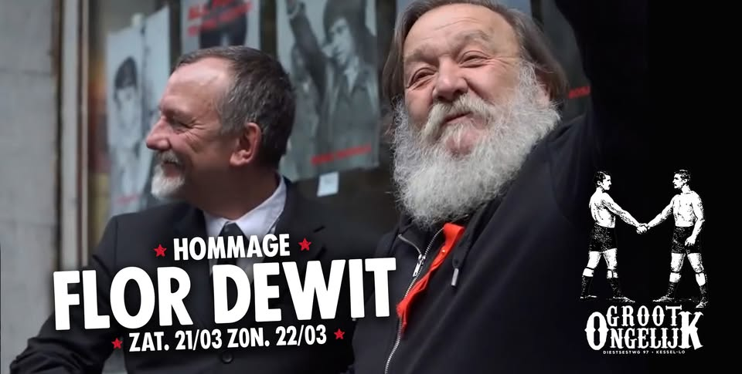Afbeelding 1: Peter Terryn (left) on the photo of the commemoration of the Communist Party of Belgium central figure (Flor Dewit, right) who died some time ago. https://www.facebook.com/events/776690591388146/
I don't really have the time to translate everything here.
If necessary, I can try to do more, but for now I have other urgent things to do, sorry.
If you postpone a decision, I can try to answer questions.
If you give me a little bit of time and help, I'm sure I can do better than them – I have never wanted to create a virtual 'organisation' like they have done. I know there are comrades you can rely on if solidarity is needed. But many comrades don't have the energy, time and money to keep a real formal organisation going – none of them ever wish to parade around waving a flag that they feel they have no right to carry as long as it's not something they feel they can make true and make real. But call on us, and we'll be there, regardless of us being a formal adherent or not.

In solidarity,
Love and rage,

J/M

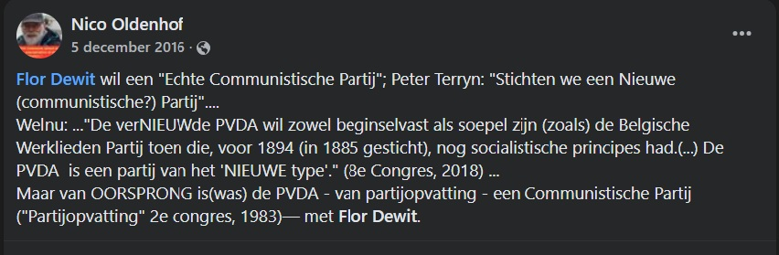Afbeelding 2: Nico Oldenhof mentioning Peter Terryn and the formation of a 'New Communist Party'

- The online attacks of CNT-b in context and with some replies as notes https://anarchistnews.org/content/rise-black-brown-nato-heartland

The rise of the black-brown in the NATO heartland
by anonymous (not verified) Dec 28, 2024

When I discussed some of these things in the comments here some people said I should write a blogpost about it, and since I have nothing else to do at the moment, here goes. This report is mostly written from the perspective of participants and supporters of the CNT-b union in Belgium but it is not any official CNT-b text, it is solely my (Tim Declercq) own personal report and responsibility.
- The first few months of war
Almost immediately after the start of the war in Ukraine in February 2022 calls were spread by some self-proclaimed anarchist groups to provide weapons and other support to people fighting in various Ukrainian militia groups. In particular these calls were spread by Vrije Bond, a group which I was still a member of at the time (I had joined in 2015). We quickly found out that many of the people being supported were part of various fascist militia groups, including the Right Sector and others. I discussed this with other people from Vrije Bond but they refused to budge and insisted on supporting these calls and not telling people about the fascist connections. So on 7 April 2022 I decided to leave Vrije Bond, it is one thing to unknowingly sponsor fascist militia groups, it is quite another to do so knowingly and willfully while trying to hide that from the people being asked to give money.
At the same time discussions about this were taking place between people from the CNT-b, where it was decided that we would refuse to support ultra-nationalist and fascist tendencies and would not move away from our position of class struggle and proletarian internationalism. As was further decided, anti-fascist groups were informed of the presence of these people in fascist militia groups, and a text exposing this was published on the Dutch Indymedia.[1] The text in question was almost immediately censored by the Indymedia team and moved to the hidden section of the site, an act of censorship that would turn out to be quite prescient for what was still to come.
- The secret union-busting campaign
At this point we are in the middle of 2022, and all that was standing in the way of this new black-brown alliance was the anarchist unions. It was at this point that Vrije Bond engaged in an extensive union-busting campaign. It should be said here that we are no strangers to union-busting efforts, after the CNT-b's involvement in the great railway strike of 2016 which came within an inch of overthrowing the government we got a good taste of this. I myself was forced into early medical retirement, Peter was getting dragged through the court system for "subversive" publications during the strike while every effort was being put into sabotaging his solidarity campaign, new laws were passed taking away railway workers' right to strike, new regulations were introduced for State Security screenings of railway personnel, etc.
The first union that would drown under the weight of this campaign was the Radical Riders union in Amsterdam (Netherlands), a union of delivery riders which had managed to win numerous fights.[2] One of its leading members, the Jewish comrade Sjerp van Wouden, informed us of an extensive use of anti-semitism during this campaign. Presumably the brown part of the black-brown alliance didn't like Jews so much, which is hardly surprising seeing how great fans they are of Stepan Bandera, Roman Shukhevych, and other Holocaust criminals.[3] The campaign against the CNT-b, and me and Peter Terryn in particular, was no less extensive though quite less effective. In this case we are talking about visits to the social center Het Groot Ongelijk in Louvain to intimidate people, death threats by the brown part of the alliance, putting people on a Myrotvorets-like website, as well as passing along names of activists to State Security. This last part did force us to pretty much lock everything down.
- One year of war
Having gained dominance in the self-proclaimed radical-left scene, the black-brown alliance had gained the self-confidence to operate more openly and brazenly. Whereas up until then most of the effort had gone into covering up and hiding the fascist connections through extensive use of censorship and secret campaigns against groups and individuals standing in the way (in particular the unions and some social centers), by now it was decided to be more open about the new alliance. As such the idea was enacted to organize a common demonstration with ultra-nationalist groups where they would march together through Brussels behind fascist slogans. This demonstration was timed for February 2023, one year after the start of the war, and was organized by several Vrije Bond groups, some self-proclaimed anti-fascist groups, and ultra-nationalist Ukrainian groups. And so this cacophony of black and brown made its way through the streets of Brussels behind screams of "Glory to the Nation! Death to its enemies!" ("Slava natsi! Smert vorogam!"), "Ukraine über alles!" ("Ukraina ponad ushe!"), and various OUN-B slogans such as "Glory to Ukraine! Glory to the heroes!" ("Slava ukraina! Heroijam slava!").[4]
Undeterred by any of this, we at the CNT-b and Het Groot Ongelijk maintained our principled opposition to this new brown-tinted nationalism that was sweeping through our movements, and remained committed to class struggle and proletarian internationalism. By now we had also gotten in touch with revolutionary trade unions in the region there, from the Donetsk miners union to the KRAS-MAT, which allowed us to fill in the details of our understanding of the situation. Despite the censorship we continued to expose these connections with ultra-nationalists and fascists in Ukraine. For example another, more detailed, exposé was published on the Dutch Indymedia.[5] Not so much because we expected it not to be censored (it quickly was) but more so as to ensure that a dated public record exists of these things so that nobody can pretend later that they "didn't know."
The censorship campaign was by now no longer limited to Vrije Bond and Indymedia NL, but included a good part of the self-proclaimed anti-fascist movement in Belgium, including Anti-Fascistisch Front and leading members of Blokbuster and CAB. By and large the very same people who had also engaged in the campaign against CNT-b after that railway strike, how little things change... All of whom were rather desperately censoring any mention of these things and banning anyone in their groups talking about it, while the promotional and sponsorship events for this new black-brown alliance were continuing at a high rate. The censorship also started hitting literally anything the CNT-b supported, even entirely unrelated to the alliance with Ukrainian ultra-nationalists, for example our calls for the Rouvikonas firetruck fundraisers or our calls for support for the Anepos solidarity convoys to Greece.
- Two years of war
The attempts by Vrije Bond to get anarchists to throw their weight behind this black-brown alliance have only accelerated. No longer content with just asking people to sponsor their friends, they have started asking people to themselves emulate and follow in the footsteps of Sergey Petrovichev ("CONTINUE THEIR WAY! WAY TO FREEDOM!" in all caps and exclamation marks).[6] It is rather a bit unclear what exactly they mean by this, as Maxim Martsinkevich is dead so it's rather difficult to take selfies with him, and White Rex doesn't hold events in Belgium or the Netherlands so it's rather difficult to make promotional material at their events.[7] At the same time, cracks have been opening in the facade due to the publications on LibCom confirming much of what we had been saying for the past 3 years.[8] Leaving the censors scrambling to cover up their role in this affair, which will inevitably fall flat on its face due to our diligence in ensuring the existence of a dated public record of it all. So make no mistake, over here in Belgium/Netherlands this information was known and discussed within a month after the start of the war.
All in all, it is rather sad that some things which have nothing to do with this had to suffer, such as the Rouvikonas firetruck fundraisers, but the positive side of this is something mentioned by an Italian comrade: "The one good thing about this war is that it shows which groups are run by the State."
Tim Declercq
1. https://web.archive.org/web/20220813005332/https://www.indymedia.nl/nod…
2. https://vrijeteelt.nl/verklaring-sjerp-van-wouden-bij-royering-uit-vrij…
3. For example from Sergey Petrovichev's group: https://www.facebook.com/permalink.php?story_fbid=pfbid0i8PmU378oKsohWv…
4. https://www.youtube.com/watch?v=yeYzkjv1CFY
5. https://web.archive.org/web/20230921213124/https://www.indymedia.nl/nod…
6. https://www.vrijebond.org/first-international-day-of-commemoration-of-t…
7. From the Facebook account of Sergey Petrovichev: https://www.facebook.com/photo.php?fbid=3293046094106365
8. https://libcom.org/article/collaboration-pro-war-anarchists-far-right-m… and https://libcom.org/article/myths-and-truth-about-enemies-our-enemies
Pictured with this article is the Belgian national-"anarchist" Jacques Guy Martin who went and fought with one of the nazi groups in Ukraine, and was well received by some self-proclaimed anarchists upon his return. (I didn't really know which picture to add to this article, so I figured this one was quite topical)

Comments

Get a website!
anon (not verified) Sat, 12/28/2024 - 07:37
Thanks for the background - very uninformed about the dutch language scene.
You/CNT-b should start your own blog to share things, instead of relying solely on other "comradely" platforms that are more likely to engage in the kind of censorship described. If that sounds like a big undertaking, try https://rant.li , https://paper.wf , or https://mataroa.blog , all of which are literally one step to register a site & immediately begin posting. If you think you can dedicate more time to it, there's https://noblogs.org or https://espivblogs.net .
- Reply

why is the anarchist movement
anon (not verified) Sat, 12/28/2024 - 08:40
why is the anarchist movement so isolated from the masses that some of its members felt the need to 1) join forces with nazis, 2) join forces with liberals, or 3) run away from the conflict altogether? this is something the piece does not tell us. thus, it does not tell us the most important thing to know.
- Reply

did someone say its members
anon (not verified) Sat, 12/28/2024 - 09:52
In reply to why is the anarchist movement by anon (not verified)
did someone say its members
- Reply

- there's no "anarchist
anon (not verified) Sat, 12/28/2024 - 10:14
In reply to why is the anarchist movement by anon (not verified)
- there's no "anarchist movement", just random anarchists
- (1) the authenticity of these "anarchists" joining forces with Nazis is forfeit. As for (2) joining liberals, some "anarchists" do that all the time. But there's nothing wrong with (3) running away from a conflict when in inferior numbers, and acktchooally... that's what Sun Tsu is urging people to do. Rightfully so.
Shitface idiots and cross-eyed noobs fighting both in the name of Bandera and Makhno can -sadly or not- get what they deserve, fighting for a Nation.
- Reply

I don't know. I don't think
Tim Declercq (not verified) Sat, 12/28/2024 - 10:35
In reply to why is the anarchist movement by anon (not verified)
I don't know. I don't think it's exactly a fair criticism that I didn't say *why* things happened the way they did, since the text never pretended to do so. I can tell you *how* things happened, as in "first this happened and then that happened and then that other thing happened...", but as to *why* things have played out the way they did? I simply don't know. I suppose I could speculate but I generally prefer to stay factual.
Some former Vrije Bond members have started a website which does try to go into more of analytical perspective of things, so maybe that has some answers for you: https://vrijeteelt.nl/ (I myself have nothing to do with this website, nor does this website go into the issues of the black-brown stuff my text was about, but maybe it has some of the answers you are looking for). Not that the black-brown issues I brought up are limited to Vrije Bond, but they are the main protagonist in this affair.
- Reply

Fair enough. Thanks for the
anon (not verified) Sat, 12/28/2024 - 12:46
In reply to I don't know. I don't think by Tim Declercq (not verified)
Fair enough. Thanks for the level headed and thorough response. It is a question really for all of us. Many just simply wash their hands of this type of crisis, but it is really important that we learn from it instead of just saying "OH no true anarchist would do X"
- Reply

you fucking moron: you were right there talking about this
CalvinSmith (not verified) Sun, 12/29/2024 - 05:56
In reply to I don't know. I don't think by Tim Declercq (not verified)
as if you wrote the article, and you even provided a link to this organization that "you were a member of in 2015", so stop with your fucking superiority bullshit. You are basically a fucking fascist, and so is every other so-called "anarchist" participating in any of the U.S. wars or offering "words of solidarity" in support of them.
And a moment ago you were telling me i have an issue with reading comprehension? Stop fucking whining about it when a stranger on the interpret "mis" interprets your shitty online politics, claiming anything on this website is "proof" of anything at all. Are you fucking aware of any of the dumb bullshit that goes down here? Goddamn.
- Reply

"you even provided a link to
Tim Declercq (not verified) Sun, 12/29/2024 - 06:16
In reply to you fucking moron: you were right there talking about this by CalvinSmith (not verified)
"you even provided a link to this organization that "you were a member of in 2015", so stop with your fucking superiority bullshit. You are basically a fucking fascist, and so is every other so-called "anarchist" participating in any of the U.S. wars or offering "words of solidarity" in support of them."
Did you perhaps miss the part where I said I left this organization in April 2022 exactly *because* of their support for fascist militia groups fighting in Ukraine? Besides, even before this I was more a member on paper than anything else, not that I was particularly involved in anything with them for years anymore. It either takes an astounding lack of reading comprehension or an equally astounding amount of bad faith to take this article I wrote and call me a "fucking fascist" for "participating in any of the U.S. wars or offering "words of solidarity" in support of them" when this whole article is basically a description of how I and some comrades have been doing the exact opposite of that.
- Reply

"your shitty online politics"
Tim Declercq (not verified) Sun, 12/29/2024 - 07:03
In reply to you fucking moron: you were right there talking about this by CalvinSmith (not verified)
"your shitty online politics"
Shitty online politics you say? Here's a picture with me on the strike committee for the Antwerp region during the great railway strike of 2016: https://imgur.com/a/IwSntgI And make no mistake here, this wasn't some average letting-off-steam strike by some reformist union, this was a wildcat strike going directly for the fall of the government - "to the finish!" (almost made it too). As I already stated in the article, our comrade Peter was later dragged through the court system for "subversive" publications during this strike, in particular a publication with instructions of how to sabotage railways (sabotage was also an intrinsic part of this strike, which made it acquire even more of an insurrectionary character https://www.nieuwsblad.be/cnt/dmf20160601_02317914). And as I also stated, I was afterwards placed in a special retirement regime which, among other things, precludes me from entering in any sort of labour relation. That is, I've been effectively blacklisted from the labour market in the whole country for the past 8 years.
So what about you, Calvin? Care to share something about your offline politics? Or is it limited to calling people "fucking fascists" online?
- Reply

Don't worry so much, comrade
anon (not verified) Sun, 12/29/2024 - 07:19
In reply to "your shitty online politics" by Tim Declercq (not verified)
Don't worry so much, comrade Tim. Apparently this guy just forgot to take his pills. Judging by his tirades, he's in a pretty gloomy state of mind right now.
- Reply

Don't worry Tim, CalvinShit's
anon (not verified) Sun, 12/29/2024 - 07:21
In reply to "your shitty online politics" by Tim Declercq (not verified)
Don't worry Tim, CalvinShit's just another somewhat-elaborate troll who occasionally uses badass insults to make himself feel superior to his online opponents while not taking the time to read things too much, Funny at times but also an asshole 24/7.
Poor, poor Calvin. Plz be more silly and less annoying.
- Reply

rather than mindlessly argue with an ideologue, i did some
CalvinSmith (not verified) Sun, 12/29/2024 - 09:48
In reply to "your shitty online politics" by Tim Declercq (not verified)
research into your original claim that there are no anarchists fighting in the Ukraine war: this is true if you believe anarchists do not participate in state conflicts, and i am fine with this assessment.
However, in the more literal sense ("fascist vs. other-ideologies"), your claims that everyone from Ukrainian paramilitary organizations does not appear to hold any water whatsoever. To back up your claim, you post pictures, and you write jibberish essays in which you expect everyone on here to believe you at face value. You have also posted an article about railroad sabotage by an organization, good for you.
Your ideological game here really does appear to be identical to Putins, in which he is claiming that because there are nazis in paramilitary organizations (and this was a known fact, for a long time), that makes the entire organization nazi, anti-immigrant, fascist, etc. So stop with the dumb conspiracy theory crap, stop getting in flame wars with people you don't know from the United States, and consider what you are saying. It doesn't actually make any sense when you look at the evidence.
Of course, I am only clarifying my rage towards you, and your zero-evidence insults, and i am just expecting you to continue with your line of reasoning (which makes me laugh, good luck with the war efforts you moron)
- Reply

"your original claim that
Tim Declercq (not verified) Sun, 12/29/2024 - 10:22
In reply to rather than mindlessly argue with an ideologue, i did some by CalvinSmith (not verified)
"your original claim that there are no anarchists fighting in the Ukraine war"
I made no such claim. Don't put words in my mouth.
"your claims that everyone from Ukrainian paramilitary organizations does not appear to hold any water whatsoever"
everyone from Ukrainian paramilitary organizations...what? This isn't even a proper sentence.
"To back up your claim, you post pictures"
The choice and reason for the picture is literally explained in the text, here I'll quote it for you: "Pictured with this article is the Belgian national-"anarchist" Jacques Guy Martin who went and fought with one of the nazi groups in Ukraine, and was well received by some self-proclaimed anarchists upon his return."
"consider what you are saying. It doesn't actually make any sense when you look at the evidence."
What I'm saying makes sense just fine. What you *imagine* I'm saying might not, but then I'm also not responsible for your imagination, so I don't see why I should care about that.
So, given that you seem reduced to just arguing against claims I never made, here's the deal: If you want to argue against something I claimed you will literally and explicitly quote the claim you're arguing against. If you're going to continue doing this "your claim of [insert some stuff you just made up yourself]" I'll simply ignore it from now on as internet noise.
- Reply

i don't think it's fair to judge the aforementioned perspectives
CalvinSmith (not verified) Sun, 12/29/2024 - 04:10
In reply to why is the anarchist movement by anon (not verified)
so quickly: even though it does seem odd that the author engages with unions and state armed forces to this degree. Like someone else pointed out, anarchism can't have members. This Tim person does have my attention for a while though, as this is not a drop form of anarchism, nor is it fully identitarian as both are popularized in the United States...the identitarian drop outs are very boring if you look beyond the indignation in their logic.
- Reply

there is a picture here of a paramilitary guy with
CalvinSmith (not verified) Sun, 12/29/2024 - 09:55
The "IN" logo, which is a nazi organization. I'm still not seeing how the picture (which is apparently proof of there only being nazis in the paramilitary groups) relates to anything in the article: Maybe Tim DeWhatever could be courteous to english language readers instead of posting links to all these dutch websites which require google translation, and still do not contain proof of any of this.
Fuck this website overall.
- Reply

wut if ya an T deC and Limpy
anon (not verified) Sun, 12/29/2024 - 10:10
In reply to there is a picture here of a paramilitary guy with by CalvinSmith (not verified)
wut if ya an T deC and Limpy are all bots and this site is just another corner of the purported dead internet...? welp, i'm gonna go keep reading anti-oedipus i guess
- Reply

good point anon! i wonder
lumpy (not verified) Sun, 12/29/2024 - 10:17
In reply to wut if ya an T deC and Limpy by anon (not verified)
good point anon! i wonder about that myself sometimes
it's like roko's basilisk or whatever, so now you must be tortured for eternity or get mind wiped

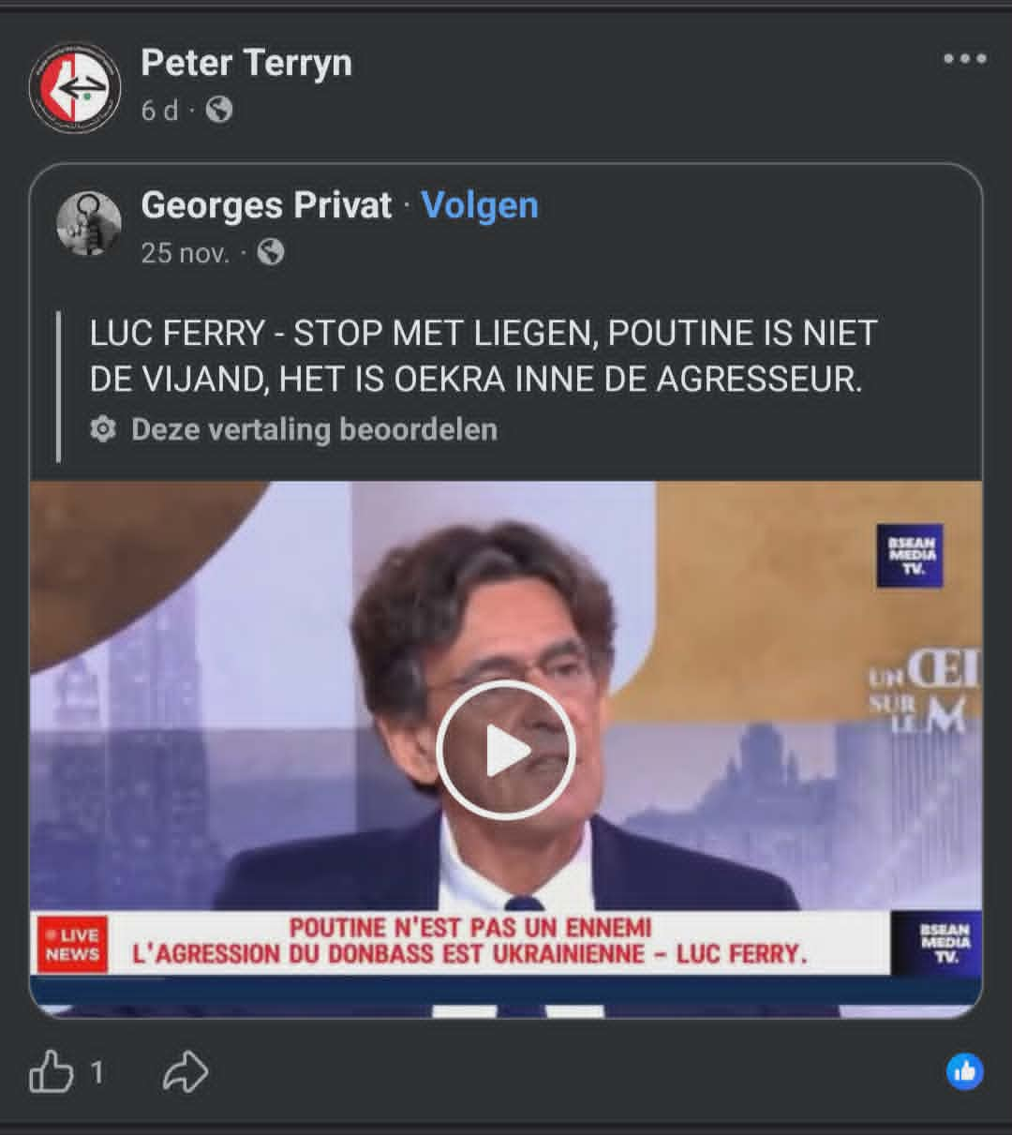
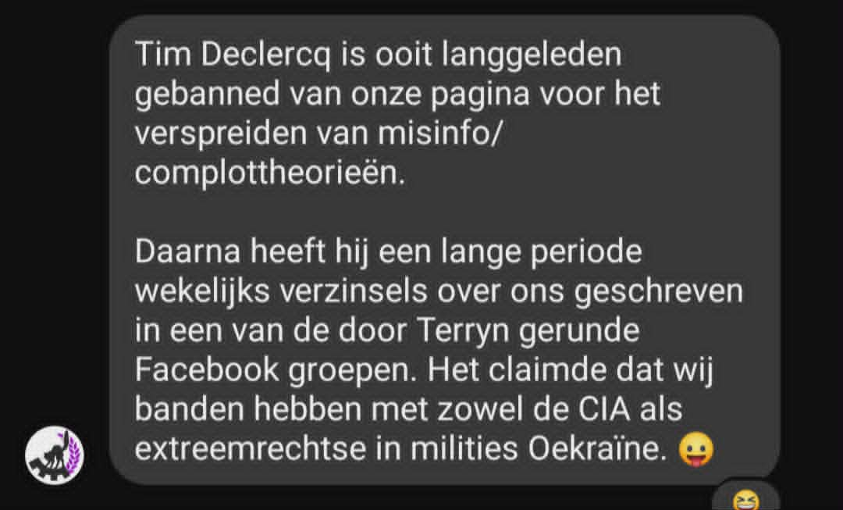

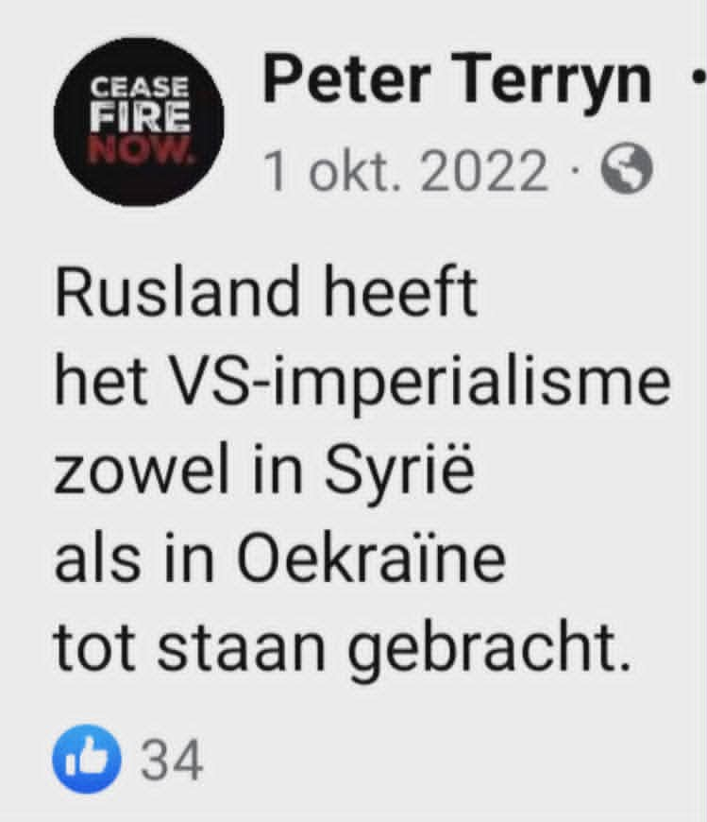

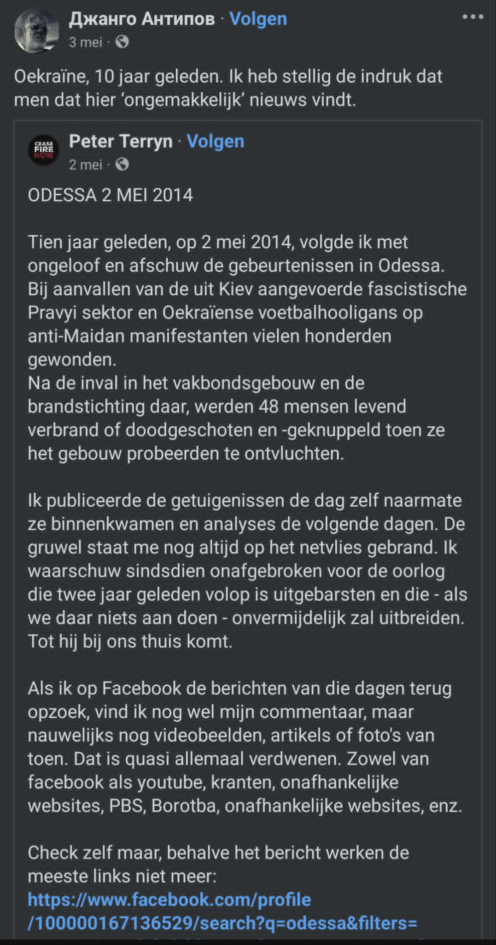
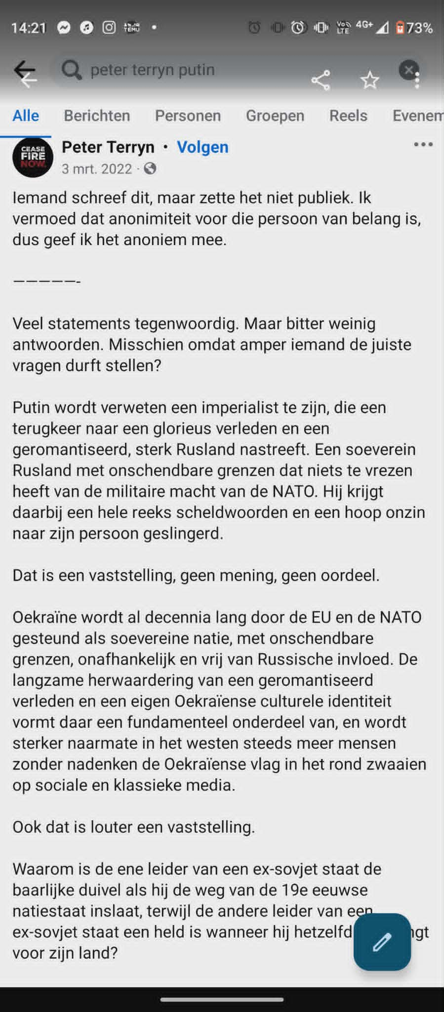

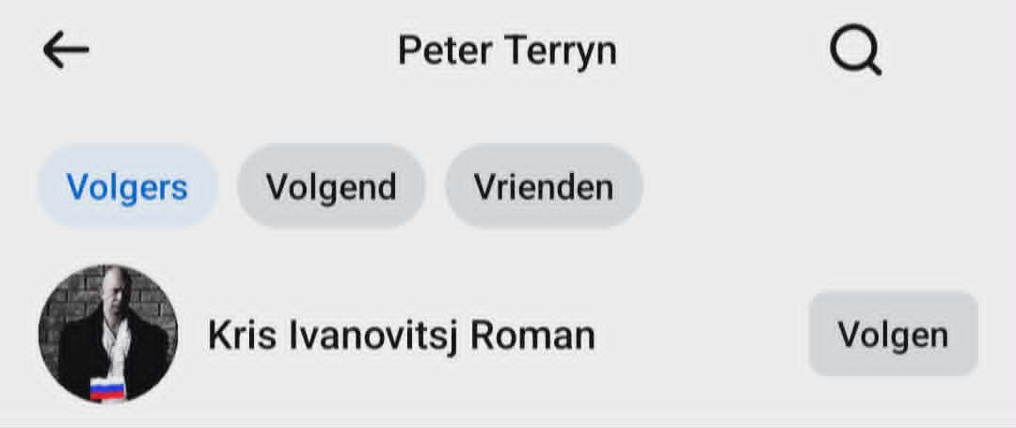

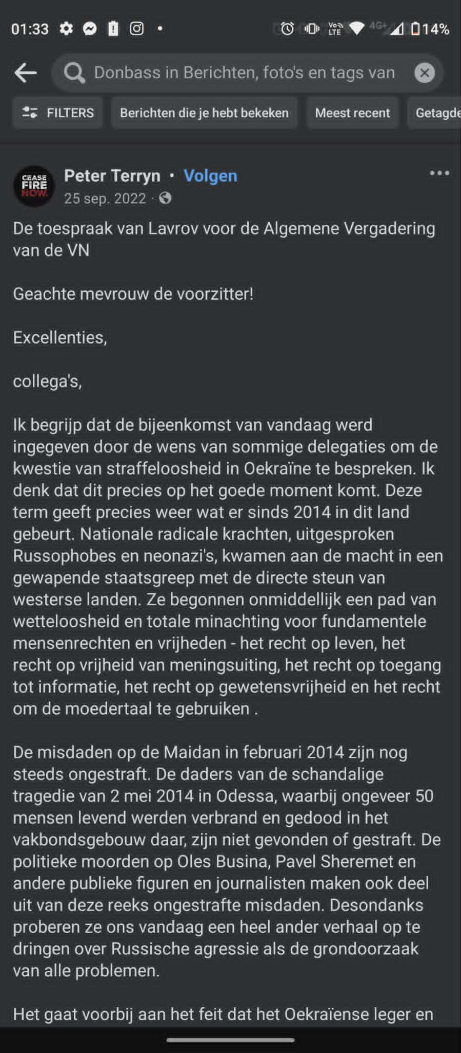
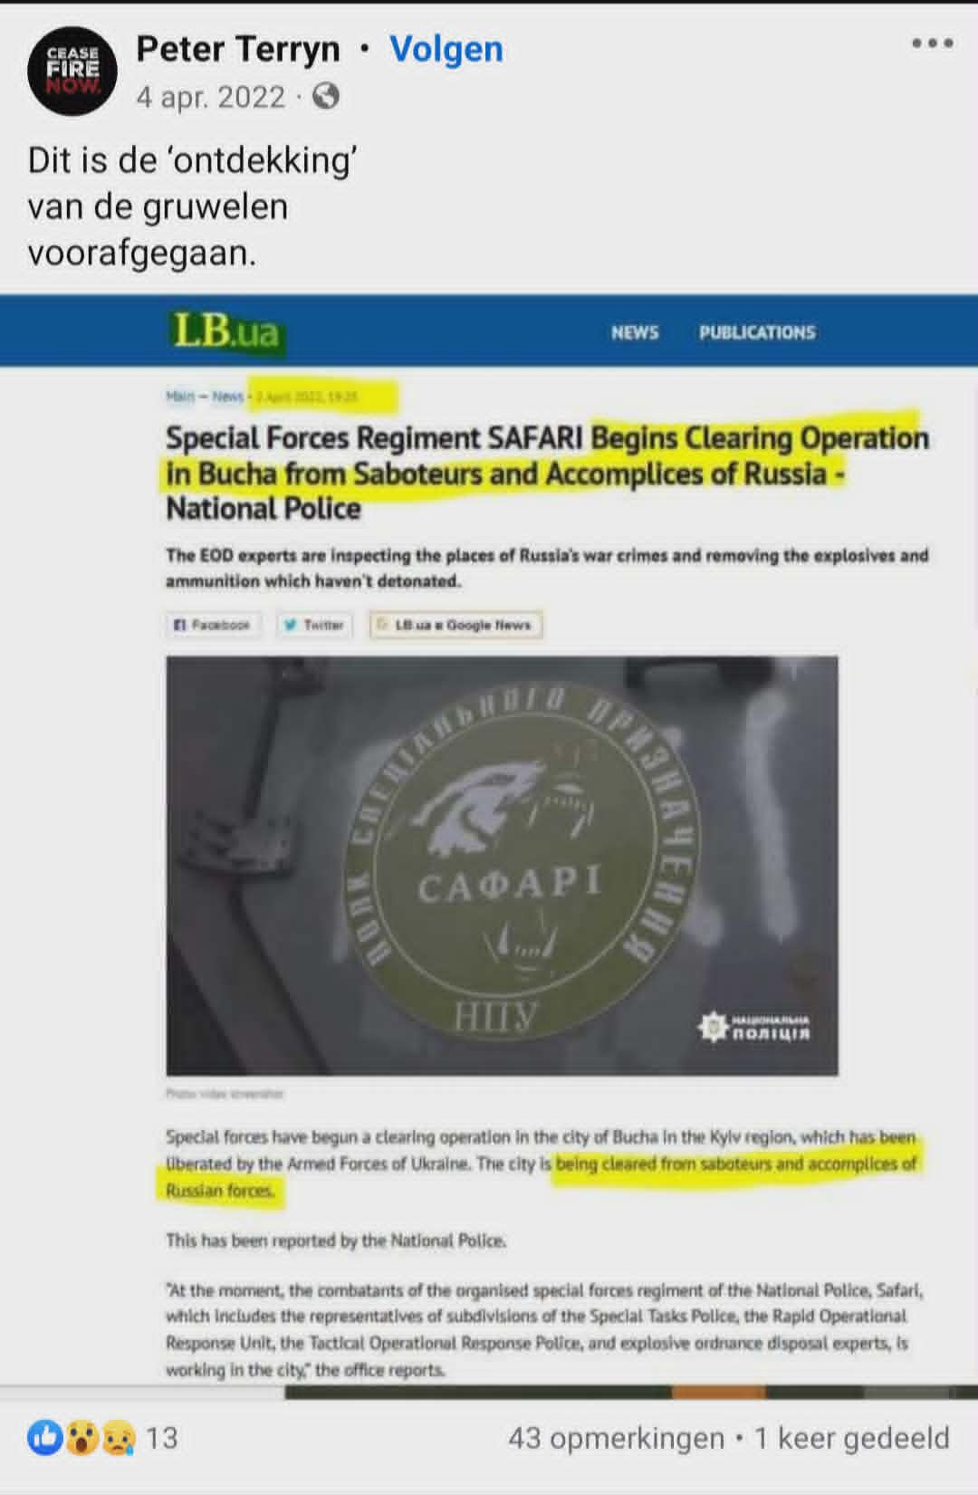

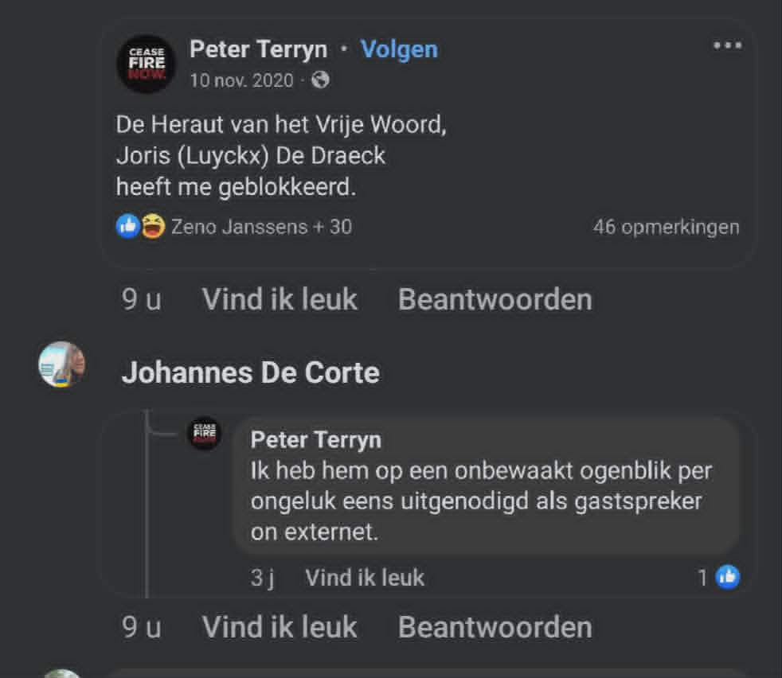
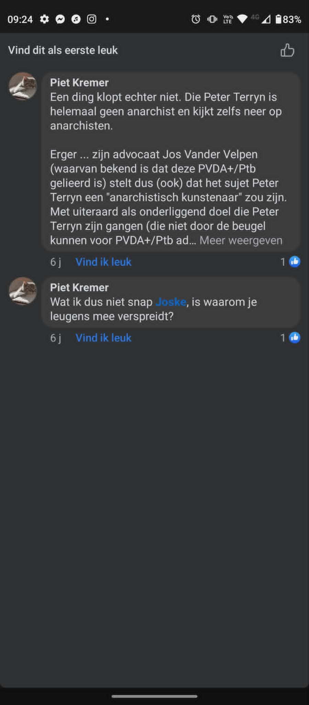
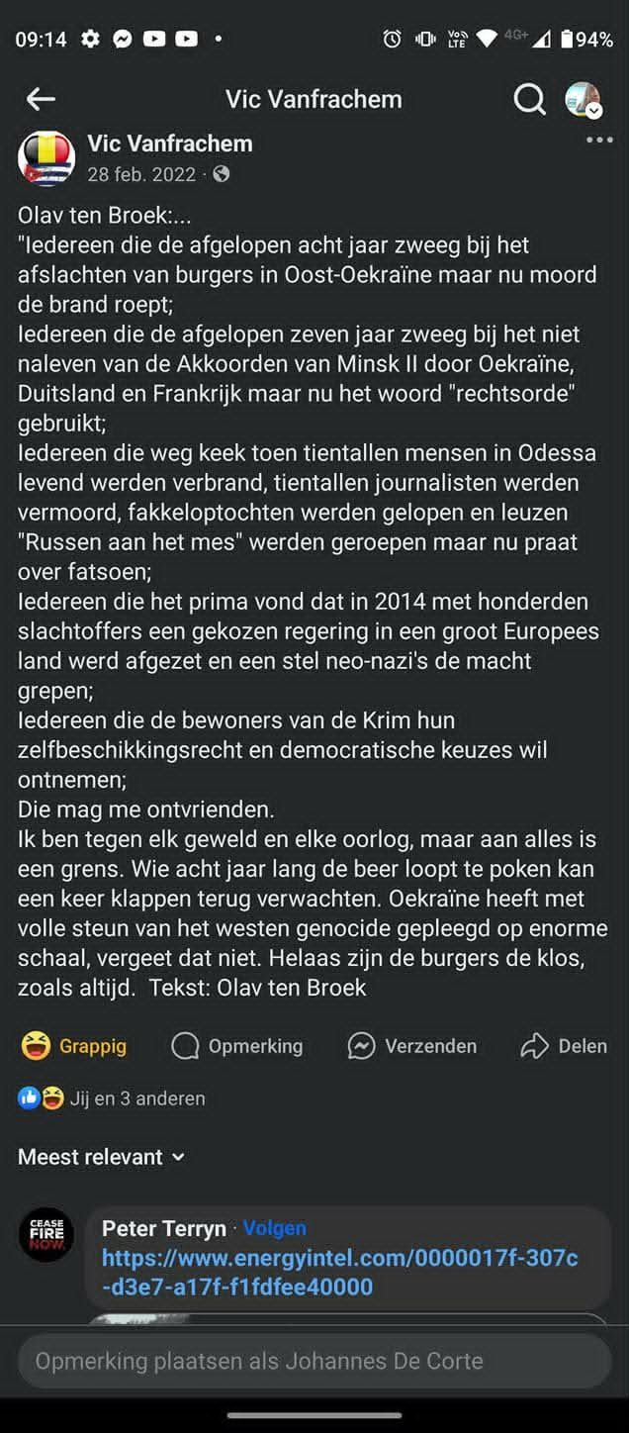

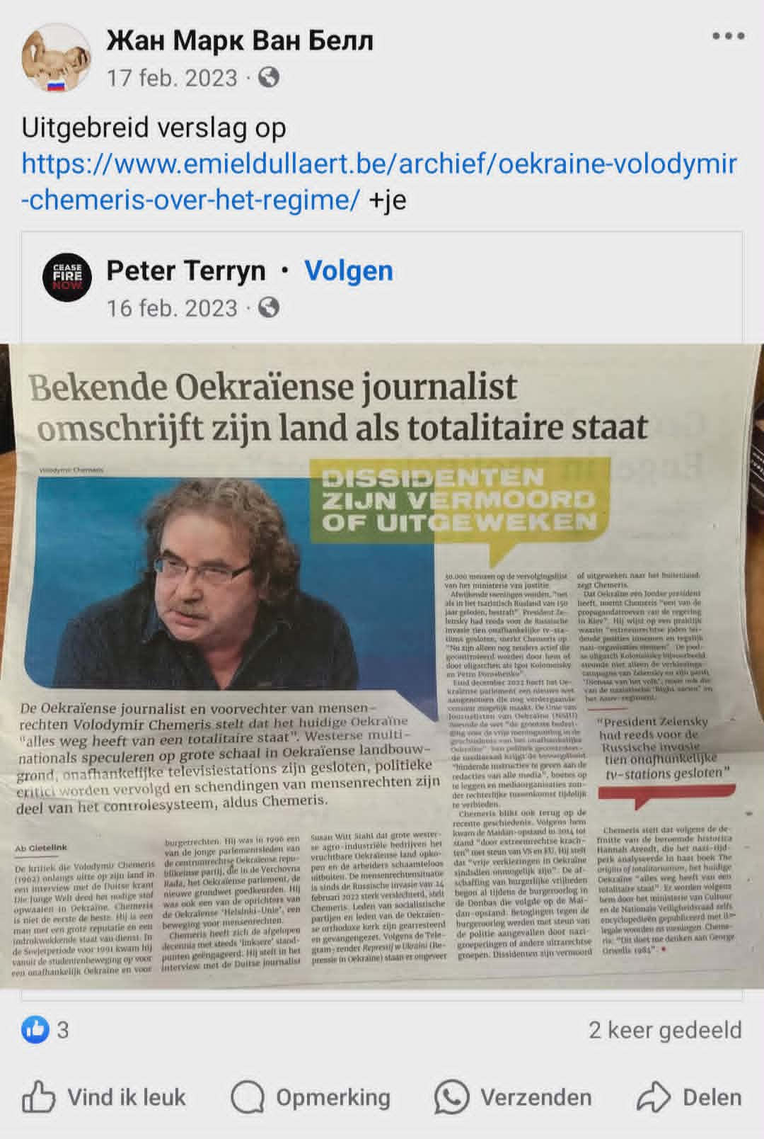
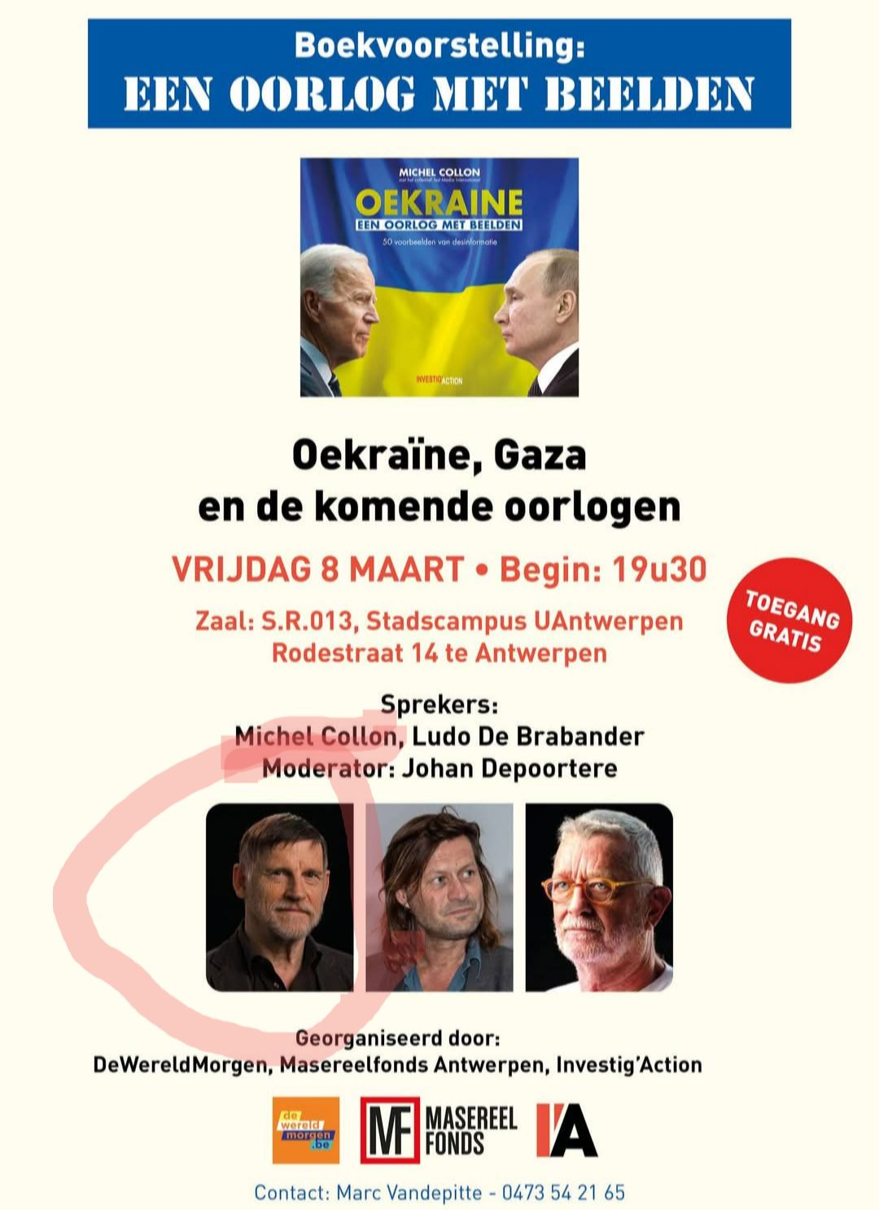
Verlies Michel Collon vooral niet uit het oog

Terryn kent: Declercq, Franky Puystjens, Brecht "Adam B" Jonkers, LDB, Kris Roman en Joris "Den Draeck" Luyckx

We hebben foto's van Joris en Roman
En van Michel Collon en Kris Roman.
Oh en Jef Helderweert Kent Jonkers en Roman van de Zannekinbond
Één roodbruine beerput

Statement of 'Vredesactie': Ludo De Brabander was "per ongeluk" terechtgekomen op de presentatie van Michel Collon's fascistische leugenboek samen met Johan "Genocide in de Donbass" Depoortere. Twee problemen: 1. Het stond en staat nog aangekondigd op de website van vrede vzw. Twee data nota bene. 2. Hij heeft minstens 5 keer samen met Collin in een pannel gezeten.

https://www.facebook.com/share/p/16L9JAxwXb/

Erik Demeester
snetdSorpo2ah hgilmom5v5rblcl0cen82f13781f2m07li7hfe01c10h2 ·

UPDATE - Programma van de Antimilitaristische Conferentie op 15 november.
16.00 uur Debat - Hoe kunnen we oorlog bestrijden? Door onderhandelingen? Diplomatie? Oproepen tot naleving van het internationaal recht? Of door klassenstrijd en socialistische revolutie? We gaan hierover in debat met Ludo De Brabander en Erik Demeester.
Ludo De Brabander is vredesactivist, schrijver en woordvoerder van Vrede vzw.
Hij publiceert onder meer in Vrede, Uitpers, Knack.be, De Wereldmorgen, en Mo*. Hij is auteur van o.a. Gaza. Een geschiedenis van kolonisatie (EPO, 2023 - samen met Soetkin Van Muylem), Weg van Oorlog. Over militarisme en antimilitarisme (EPO, 2019), Als de NAVO de passie preekt (EPO, 2009), Het Koerdisch Utopia (EPO, 2018) en Oorlog zonder Grenzen (EPO, 2016).
Erik Demeester is redacteur van Vonk/Révolution, de tijdschriften van de Revolutionair Communistische Organisatie.
Hij trok mee de Shipspotting campagne tegen het gebruik van de Antwerpse haven als logistieke draaischijf van de oorlog tegen Irak. Hij werkte ook mee met de jaarlijkse Vredesconferenties nadien. Is auteur van verschillende artikels over oorlog, vrede en marxisme.

In deze wedstrijd "om ter meest ranzige fascistische oorlogspropaganda uitbraken voor onze broodheer Putin" zien we:
- NAZBOL Neofascist Michel Collon. Ik had het graag gehad over de Belgische Kremlinpropagandist Michel Collon.
Vrij berucht in het Franstalige gebied maar redelijk onbekend daarbuiten.
Collon staat bekend om zijn roodbruine discours.
Zijn laatste boek "Oekraïne: een oorlog met beelden" is daar een prima voorbeeld van.
In de laatste drie jaar heeft de reguliere media zich soms schuldig gemaakt aan het publiceren van overdreven verhalen, urban legends en clickbait.
Geen van deze futuliteiten veranderen de kern van de zaak: de oorlog in Oekraïne is fascistsch imperialisme gebaseerd op regelrechte leugens zoals "genocide in de Donbass", dat de NAVO een bedreiging zou vormen voor Putin of dat een land met twee Joodse centristen respectievelijk als president en eerste minister een Nazi staat zou zijn.
Het tweede gegeven wordt staal genegeerd.
De weinig significante onjuistheden on de reguliere media- wordt door Collon in het lang en in het breed uitgesmeerd alsof dat iets zou veranderen aan de kern van de zaak.
Russische leugens, excuses en oorlogsmisdaden worden door hem genegeerd of gelegitimeerd.
Over het bombarderen van materniteit bekend vanwege de iconische foto van de vluchtende hoogzwangere Marianna Vyshemirskaya had hij het volgende excuus bedacht:
dat ziekenhuis was geen doelwit op zich maar stond toevallig in de vuurlinie (?) en het werd zogezegd gebruikt als schuilplaats voor Oekraïense troepen. ...is dat even een meevaller.
Hoe een ziekenhuis "toevallig" in de vuurlinie kan liggen is mij een raadsel.

In een interview met andere "De Wereld Morgen" Kremlinpropagandist Johan De Poortere noemde hij het doodschieten van demonstranten op de Euromaidan "een uitgelokte slachting".
Volgens Vrede vzw en DWM propagandisten Ludo De Brabander en Christophe Callewaert hun leugenboek "Oorlogskoorts" is het onduidelijk wie de schuldige van die slachting is -vaagweg insinuerend dat de Russische complottheorie over een false flag wel een zou kunnen kloppen- volgens Collon was het een "uitgelokte slachting".

Kremlinpropagandist Johan Depoortere beschuldigde Oekraïne van "genocide in de Donbass" en "de moord op talloze kinderen" een leugen zo grotesk dat zelfs de bedenker Putin ze niet meer herhaalt.
https://www.masereelfonds.be/johan-depoortere-oorlogspropaganda-en-propagandaoorlog/
MASEREELFONDS.BE
Johan Depoortere - Oorlogspropaganda en propagandaoorlog - Masereelfonds

Johan Depoortere - Oorlogspropaganda en propagandaoorlog - Masereelfonds

DIT is NAZBOL Neonazi Kris Roman. Iemand die Putin's tankbatallions ging bevoorraden.
Ludo De Brabander's vriend Michel Collon ging de uitgave van zijn fascistsche leugenboek vieren met zijn pro Putin fanclub waaronder Kris Roman.
Leuke kringen waarin Comrade De Brabander zich in ophoudt.
https://www.hetobservatorium.be/2022/02/27/kris-roman-een-21ste-eeuwse-pro-russische-cyriel-verschaeve/

HETOBSERVATORIUM.BE
Kris Roman, een 21ste eeuwse pro-Russische Cyriel Verschaeve – Het Observatorium

Kris Roman, een 21ste eeuwse pro-Russische Cyriel Verschaeve – Het Observatorium

Op de foto's hierboven: Kris Roman, Michel Collon en de rest van de Pro Putin NAZBOL Neofascisten.
Collega van de andere Kremlinpropagandist Ludo de Brabander bij De Wereld Morgen, een medium dat letterlijk elke fascistische leugen uit Rusland over Oekraïne verspeidt heeft.
Indien u een overzicht van hun leugens wilt vraag gerust.

*DAT* is waar u zich nu mee inlaat Erik Demeester: een verspreider van Fascistsche leugens en in mijn ogen te nauw betrokken bij het NAZBOL milieu om hem ervan vrij te pleiten er zelf één te zijn.

Cnt Belgie Peter Terryn zijn twee vriendjes die samen de publicatie van zijn fascistsche leugenboek vieren.
Waarschijnlijk zal hij nu opeens Michel Collon ook niet meer kennen.

Cnt Belgie heeft geen enkel probleem met Ludo De Brabander en Peter Terryn's Neofascistische vriendje Michel Collon. Is genoteerd.

- Cnt Belgie
Voor verdere informatie hierover, verleden jaar werd 1 van onze leden gevraagd door de voornaamste internationale anarchistische nieuwswebsite om een artikel te schrijven over deze ontwikkelingen in onze regio: https://anarchistnews.org/content/rise-black-brown-nato-heartland

ANARCHISTNEWS.ORG
The rise of the black-brown in the NATO heartland | anarchistnews.org

The rise of the black-brown in the NATO heartland | anarchistnews.org

Pieter Vanderwee
Cnt Belgie i repeat: waart ge daar sabotageacties aant bekennen nadat uw kameraad vrijgesproken werd?

Cnt Belgie
Pieter Vanderwee Helemaal niet. Tim was gewoon de context aan het schetsen dat de spoorwegarbeiders autonoom zelf beslist hadden om sabotage als middel te gebruiken in die strijd, iets wat overigens algemeen bekend is en niets nieuws is. Het is net om die reden dat onze kameraad Peter vrijgesproken werd, omdat het de Staat niet gelukt is om die acties in zijn schoenen te schuiven. Als anarcho-syndicalistische vakbond staan we uiteraard positief tegenover de autonome acties van de arbeiders in strijd, inclusief het gebruik van sabotage als middel, maar dat betekent daarom niet dat wij die sabotages gepleegd hebben noch dat wij daar de aanleiding toe zouden zijn.

Pieter Vanderwee
Cnt Belgie er staat te lezen: "sabotage was also an intrinsic part of this strike, which made it acquire even more of an insurrectionary character". Vertaald naar het Nederlands via Deepl: "sabotage was ook een intrinsiek onderdeel van deze staking, waardoor deze nog meer een opstandig karakter kreeg". De betekenis van "intrinsiek" volgens Van Dale: "in·trin·siek (bijvoeglijk naamwoord, bijwoord)
1wezenlijk, innerlijk". "Also"/"ook" verwijst in de tekst naar "in particular a publication with instructions of how to sabotage railways" door Peter Terryn, volgens de tekst deel van de "strike" en de deelnemende vakbond. Dat sloeg dus niet enkel op "spoorwegarbeiders" maar fijn dat Tim/jij die er meteen bij betrok, met foto.

Cnt Belgie
Pieter Vanderwee Als je enigszins bekend zou zijn met die rechtszaak dan zou je weten dat Peter dat pamflet gepubliceerd had nadat hij daar door sommige spoorwegarbeiders voor gecontacteerd was nadat die spoorwegarbeiders autonoom beslist hadden om sabotage te hanteren als middel in die spontane strijd. Met andere woorden, het was niet het pamflet dat de aanleiding was van de sabotage maar de beslissing om sabotage te gebruiken dat de aanleiding was van het pamflet. Dus ja, die sabotage was een intrinsiek onderdeel van die strijd, het waren een deel van de spoorwegarbeiders die spontaan beslist hadden over te gaan tot staking die enkele dagen later spontaan beslist hadden om sabotage als middel te hanteren. En dat pamflet vormde daar ook een intrinsiek onderdeel van, het waren enkele van die spoorwegarbeiders die Peter daarop gecontacteerd hadden om hun beslissing over te gaan tot sabotage publiek te maken. In plaats van hier opnieuw de rechtszaak te proberen voeren zou je misschien best eens de rechtsbanksdocumenten doorlopen, die zaak is al een keer gefaald om goede redenen.

Cnt Belgie
En als anarcho-syndicalistische vakbond staan we daar natuurlijk allemaal ten volle achter, maar dat betekent geenszins dat wij die sabotage acties gepleegd zouden hebben. Onze positie is altijd met de autonome strijd van de arbeiders, inclusief als deze beslissen sabotage als middel te gebruiken, en dat is simpelweg wat er daar toen gebeurd is.

Pieter Vanderwee
Cnt Belgie het zal je opgevallen zijn dat "sabotage" daar op zichzelf staat. Niet "de beslissing om sabotage te gebruiken". Bedankt om de foto erbij te zetten.

Pieter Vanderwee
Cnt Belgie het fijne is dat Tim Declercqs bijdrage ondubbelzinnig een geschreven instructie tot spoorwegsabotage van Peter Terryn linkt met een foto van een "strike comitee" en de boodschap dat dat soort sabotage een intrinsiek onderdeel was van die mensen hun acties. Ergo: strafbare feiten. Ik ken er alles van, en terecht.

Cnt Belgie
Pieter Vanderwee Nee hoor, allemaal je eigen fantasie. Wat Tim stelde was dat hij op die foto van dat stakingspiket stond, wat ook zo is. Daarnaast, en los daarvan, gaf hij meer informatie over die staking zoals het gebruik van sabotage als strijdmiddel door een deel van de stakers. Nergens wordt er gesteld of ook maar geïmpliceerd dat de mensen op die foto ook maar iets met die sabotage acties te maken zouden gehad hebben. Denk je echt dat die spoorwegstaking maar uit een 10-tal mensen bestond die op die foto staan? Oh ja, en die foto was van het piket in Antwerpen terwijl het gros van de sabotage acties in Wallonië plaatsvonden.
Maar laat dat alles zeker je intrigantenwerk niet tegenhouden hoor, amuseer je maar met deze laatste wilde beschuldigingen van je als zouden de mensen op die foto sabotagedaden gepleegd hebben. Ik stel wel voor dat je dat in de AFF groep doet, daar houdt de beheerder immers ons (en anderen) tegen om je wilde beschuldigingen tegen onze leden te weerleggen. Terwijl hier op het profiel van Erik we gemakkelijk je beschuldigingen kunnen weerleggen en je dus steeds een beetje afgang maakt met je intrigantenwerk.

Pieter Vanderwee
Cnt Belgie ik zeg nergens dat de mensen op die foto sabotageacties pleegden. Ik schreef dat Tim dat verband legde.

Cnt Belgie
Pieter Vanderwee Tim legde dat verband toch helemaal niet. Als je kijkt naar de comment waarop Tim reageerde zie je dat de commenter Tim ervan beschuldigde enkel aan "online activisme" te doen. Tim deelde dan die foto om dat te weerleggen en bewijs te geven van concrete werking in arbeiderstrijd. Daarnaast, en los daarvan, gaf Tim meer uitleg over die staking in kwestie waaronder het gebruik van sabotage door een aantal van de stakers. Nergens echter stelde of impliceerde Tim dat er een verband bestaat tussen de specifieke mensen op die foto en de specifieke sabotage acties die tijdens die staking voorkwamen.

Pieter Vanderwee
Cnt Belgie dat legde ik hier al uit; altijd bereid om dat verder uit te diepen. Ik plaatste trouwens geen foto van die mensen maar een link gekregen van Tim en een gearchiveerde link naar die gekregen afbeelding die door Tim online werd gezet. Vraag in de eerste plaats aan die mensen wat ze van Tims verbandlegging tussen "sabotage was also an intrinsic part of this strike, which made it acquire even more of an insurrectionary character", Peters pamflet, en hun foto vinden.

Cnt Belgie
Pieter Vanderwee Zoals gezegd, Tim legt dat verband met die foto niet, jij doet dat. En dat niettegenstaande het je al uitgelegd is dat er geen verband bestaat en dat die foto eens uit de juiste regio kwam (foto van antwerpen, sabotage acties vnl in wallonie). Net zoals jij degene bent die hun foto op je profiel deelt met tags als "MouvementNation", "KrisRoman", en "DuginNetwork" om te insinueren dat de mensen op die foto daar iets mee te maken zouden hebben. Op die andere wilde beschuldigingen en insinuaties in die screenshot die je nu geeft is trouwens ook al afdoende gereageerd. Nogmaals, ik stel voor dat je met die dingen naar de AFF groep trekt, daar is het onze vakbond noch onze leden toegelaten om te reageren op je intrigantenwerk. Hier val je immers toch maar steeds direct door de mand met je valse beschuldigingen en insinuaties.

Pieter Vanderwee
Cnt Belgie dit is duidelijk een verbandlegging door Tim. Want: 1 coherente tekst met vermelding van die foto, de link ernaar, de omstreden quote over sabotage, Peters pamflet en het verbindende woord "strike". Niet eens? Dien klacht in. Geen zin in? Slik het als een man en stfu.

Cnt Belgie
Pieter Vanderwee Zoals gezegd, trek ermee naar de AFF groep zodat het beheer ervoor kan zorgen dat je niet tegengesproken kan worden door degenen die je beschuldigt. Want hier ga je echt af als een gieter, net zoals elders waar tegenspraak op je aantijgingen toegelaten is (het is bvb opmerkelijk dat je niet besloten hebt om zulke reacties te geven op het originele AnarchistNews hoewel commenting daar open staat)

Pieter Vanderwee
Cnt Belgie dat doe ik ook niet. Tim legde het verband met sabotage. Jij legde dat. En ik leg het verband met de aard van die betoging waaraan Nation meedeed: puur voor russische belangen; zowel vanuit organisatie (die in rechtstreeks verband staan met Schild&Vrienden, Kris Roman en een persoonlijke vriend van Alexander Dugin, Robert Steuckers) als deelnemers zoals Nation. Dat Peter de fasco besmetting van een organisatie waar hij het woord voor voerde nooit benoemde, is Peters gebrek. Niet het mijne.

Cnt Belgie
Pieter Vanderwee Voor de laatste keer, Tim legde geen verband tussen die foto en sabotage, jij bent de enige die dat doet. Dat Peter zogezegd woordvoerder zou geweest zijn van een organisatie waar Nation aan deelnam is ook niet meer dan je eigen fantasie, Peter staat niet eens op die foto die je als "bewijs" daarvoor gebruikt, je intrigantenwerk is gewoon van belachelijk niveau. Maar toen we daar probeerden op te wijzen in het AFF werden onze reacties weer verwijderd, dus opnieuw, trek ermee naar het AFF zodat ervoor gezorgd kan worden dat je niet zo afgaat als een gieter zoals steevast gebeurt wanneer het toegelaten wordt om tegen je aantijgingen in te gaan.

Pieter Vanderwee
Cnt Belgie ga ik niet doen want *jij* leest dat erin. Ik zie hen hoogstens als Nuttige Idioten.

Cnt Belgie
Pieter Vanderwee En hier is de foto van die actie aan AB-Inbev. Waar zien we daar Nation of eender welke andere extreem-rechtsen? Dat is juist, nergens! Want die worden natuurlijk niet toegelaten. Zoals gezegd, je intrigantenwerk is van belachelijke kwaliteit, trek ermee naar de AFF groep zodat ervoor gezorgd kan worden dat je niet steeds zo afgaat als een gieter. En nu gaan we het hierbij laten, wij hebben immers belangrijkere dingen te doen zoals onze vakbondspermanentie straks bemannen en onze documentaireavond doen.

Pieter Vanderwee
Cnt Belgie ah kijk, gij kunt een unieke foto delen van een Gele Hesjes-actie. Dat toont betrokkenheid. Emotionele betrokkenheid. Mag ik u dan dezelfde vraag stellen als aan Peter? Wat vind je van Nation die onder ex-Voorposter Marko Kleijn terechtkwamen, die op zijn beurt Nation gele hesjes liet aantrekken? Die dan op hun beurt lieten weten een handpop te zijn voor Dugin? En op die betoging ingezet werden ten dienste van een vriend van Dugin die Feniks hielp oprichten die daar steward waren samen met mensen van Schild&Vrienden?

Cnt Belgie
Pieter Vanderwee Nee Pieter, hoewel verschillende van onze CNT-b leden aanwezig waren op die actie aan de AB-Inbev, heeft dit niets te maken met emotionele betrokkenheid. Jij bent degene die Peter ervan beschuldigde woordvoerder te zijn van een organisatie waar Nation aan deelnam en haalde die actie aan AB-Inbev aan als bewijs, waarop je de foto van die specifieke actie getoond werd waar iedereen van kan zien dat niemand van Nation aanwezig was. Net zoals iedereen kan zien dat noch Peter noch iemand van onze andere leden op die Nation foto staat die jij hier geeft. Het is dus allemaal gewoon weer niets anders dan je typische valse beschuldigingen en insinuaties naar onze leden toe.
Ja Pieter, we weten allemaal dat de staatsveiligheid bezorgd is om een anarcho-syndicalistische vakbond in de spoorwegen en er alles aan doet om het ons moeilijk te maken, waaronder het intrigantenwerk van jezelf en mensen als Johannes. Maar op plaatsen zoals het profiel van Erik Demeester waar het ons toegestaan is om jouw intriges te weerleggen hebben we er duidelijk geen probleem mee om de bewijzen te tonen, zoals de fotos van die actie aan de AB-Inbev, die je steeds doen afgaan als een gieter.
Zoals gezegd, we hebben belangrijkere dingen te doen. Ofwel kom je af met ook maar het minste bewijs voor je aantijgingen, zoals een foto waar zowel iemand van onze leden als iemand van Nation opstaat (niet dat zulk een foto bestaat aangezien wij, als anarcho-syndicalistische vakbond, anti-fascistisch zijn en Nation et al bestrijden) ofwel laat je ons vanaf nu gewoon met rust. Er wordt niet verder gereageerd hier op je intriges, zoals eerder gezegd, trek ermee naar de AFF groep waar die dingen welkom en beschermd zijn.

Pieter Vanderwee
Cnt Belgie ik stel alleen maar vragen aan een vakbond die zich ondubbelzinnig verbindt met een organisatieverband dat besmet werd door russische handpoppen en zelf aangeeft dat leden tot sabotage overgingen; toevallig iets waar rusland al een paar jaar voor recruteert. Waarom stoort het jou zo dat ik daarop inga?

Johannes De Corte
Pieter Vanderwee CNT België is Tim zelf dat is toch klaar en duidelijk?

Pieter Vanderwee
Johannes De Corte hij spreekt in de 3de persoon enkelvoud over Tim dus dan volg ik dat maar.

Cnt Belgie
Johannes De Corte Hier dan toch iets waar we akkoord mee gaan, Peter had inderdaad beter gebruik gemaakt van lokale anarchistische bronnen in plaats van de burgerlijke media om die informatie te delen. Zoals de tekst van de voorzitter van de Unie van Anarchisten van Oekraïne SAU over dat onderwerp: "Het is niet nodig om degenen in de Oekraïense samenleving die de staatsgreep afwezen te herinneren aan de schokkende impact van de dominantie van extreemrechtse groeperingen op straatniveau die zich direct na Maidan in 2014-2016 in het land ontvouwde. Om de ongehinderde implementatie van neoliberale hervormingen te garanderen, die leidden tot de dramatische verarming van brede lagen van de bevolking, transformeerde het Porosjenko-regime rechtsradicalen tot een ondermaatse verlengstuk van de politie, belast met de onderdrukking van elk sociaal protest. Dit was een exacte kopie van de Latijns-Amerikaanse junta's, een instrument van de Pinochets. Zware mishandelingen, martelingen en zelfs moorden op tegenstanders van het regime werden nooit onderzocht; de nazi's kwamen overal mee weg. {...}" https://www.azarov.net/comprehension/practic/356-how-the-nazis-were-asking-for-anarchists.html
Maar zelfs dan nog is dit slechts een héél klein puntje van kritiek, het belangrijkste is immers de informatieve inhoud en de voorkeur voor bronnen uit de anarchistische beweging ipv burgerlijke journalisten is secundair.

AZAROV.NET
Как нацисты в анархисты напрашивались

Как нацисты в анархисты напрашивались

Cnt Belgie
Pieter Vanderwee Ik had het uiteraard over Volodymir Chemeris, die zijn uitleg in het afgebeelde artikel doet. Die Jef Helderweert interesseert mij niet, en volgens die screenshot is het trouwens die Jef die iets van Peter deelt en niet andersom zoals jij beweert, niet dat het overigens iets zou uitmaken. Zoals al zoveel gezegd is, jullie intrigantenwerk is belachelijk, en de enige reden dat er hierop eigenlijk maar gereageerd werd in de eerste plaats was omdat het duidelijk was dat Johannes wou staan doen alsof de verklaringen van burgerlijk journalist Volodymir Chemeris onwaar zouden zijn hoewel dat ook allemaal terug te vinden is bij de lokale anarchistische groepen daar.

Cnt Belgie
Pieter Vanderwee Zo lang geleden zal je hem dan niet geblokkeerd hebben want 12 uur geleden zat hij nog te reageren op je profiel. En het verband is dat het van hetzelfde niveau is als wat jullie doen. Volgens jullie is Jef Helderweert een vriend van Kris Roman en Jef heeft ooit eens iets van Peter gedeeld op facebook dus is Peter een "spilfiguur" van het neo-fascisme. Volgens dezelfde standaard kan je argumenteren dat Stefanos vrienden is met jou en Stefanos heeft ooit eens zijn steun bij Constant Kusters geuit dus zit jij nekdiep in het Nederlandse neo-nazi milieu. Zie je hoe gemakkelijk het is om met jullie "onderzoeksniveau" eender wat te bewijzen wat men wil?
En trouwens, het is niet omdat een nazi ambras heeft met een andere nazi dat het daarom plots een anti-fascist zou zijn. Uw ambras met sommige nazis als Boutens of Roman betekent helemaal niets, al zeker niet gelet op hoe ge er geen probleem mee hebt/had om om te gaan met andere nazis die toevallig ook ambras hebben met Boutens/Roman/etc zoals Ben van der Kooi of gelinkt zijn aan Constant Kusters, kort gezegd, dat deel van extreem-rechts dat toevallig pro-Oekraïns is net zoals jij.
Je bent gewoon een ordinaire fascist die toevallig ambras heeft met wat andere fascisten en daarom denkt dat ie een anti-fascist is. Niets meer of niet minder.

Pieter Vanderwee
Cnt Belgie super, ik lees dat je Kris Roman een nazi noemt. Kan je dat, aub, ontlokken van Peter Terryn en hier posten? Want daar draait het hier juist rond: Peter benoemde dat nooit; Peter zweeg over de fascistische besmetting van zijn Gele Hesjes: Peter zwijgt over de fascisten bij Zannekinbond. Peter heeft nochtans een grote mond, behalve over zaken die hem raken.

Cnt Belgie
Pieter Vanderwee Ja ik noem Kris Roman een fascist net zoals ik jou een fascist noem. Het enige verschil tussen jullie is dat jullie samen met jullie respectievelijke milieus vol andere extreem-rechtsen ofwel pro-Rusland ofwel pro-Oekraïne zijn. En nee, noch Peter noch ikzelf noch eender wie is u eender wat verschuldigd. Jij hebt niets, maar dan ook niets, met anti-fascisme te maken, je bent gewoon een fascist die ambras heeft met sommige andere fascisten. Denk je echt dat wij als anti-fascisten ook maar iets verschuldigd zijn aan fascisten? Nee. En al zeker niet aan eentje die er zijn levensmissie van gemaakt heeft intrigantenwerk onder anti-fascisten te verrichten.

Pieter Vanderwee
Cnt Belgie hier is trouwens een schitterend voorbeeld van wat ik doe; vers van de pers! Waarom zet Peter geen druk op die nazis zoals jij het zo succinct wist samen te vatten? Waarom zwijgt hij in alle talen over de massale beïnvloeding en misinformatie vanuit die ranzige fascist? Waarom zegt Peter NIKS over Schild&Vrienden die daarmee samenwerken? Dat is toch topnieuws bij uitstek, dat bewijst toch de hang naar collaboratie onder die fckers? Maar nee, Peter KIEST om daarover te zwijgen. Hij KIEST om die vrij spel te geven terwijl iemand van zijn kaliber al veel efficiënter dan een sukkel als ik die mensen het leven zuur kon maken.

Johannes De Corte
1. Ah dus als Kris Roman, Brecht Jonkers en Peter Tuinstoel's [i.e. Peter Terryn] vriendje fascistsche leugens van Peter Tuinstoel deelt dan is het OK? Een artikel van Ab Gietelink FFS... Over fascist nummer 4 die klaagt dat collaboratie met Nazi Rusland strafbaar is...
Straf ook dat een paranoïde shizofr... wantrouwige mens als gij zijn lijsten nooit nagetrokken hebt maar meteen met uw grenzeloze fantasie een verklaring verzon.
2. De Euromaidan was géén coup. Fascistsche leugen. Een fascistsch staatshoofd door het parlement laten afzetten als hij met scherp op betogers laat schieten is *democratie*, bruinhemd.
3. Ge loog ook over Stanislas de NAZBOL en de jankreactie onder het artikel over verkr8er Gonzalo Lira.
Echt... Ik heb nog geen tekens van fascistische sympathieën en leugens bij Ben Van Der Kooi tegengekomen... Bij u daarentegen...

Cnt Belgie
Johannes De Corte Als Tim zulk een "paranoide schizofreen" is waarom wordt hij dan als goede "reality check" omschreven op de voornaamste internationale anarchistische nieuwswebsites? Tijdstip 2:56 https://anarchistnews.org/content/anews-podcast-441-111425
Het blijft toch grappig hoe jullie steevast onmiddellijk afgaan als een gieter de moment dat jullie je zorgvuldig beschermde omgeving in de AFF groep verlaten...

ANARCHISTNEWS.ORG
ANews Podcast 441 – 11.14.25 | anarchistnews.org

ANews Podcast 441 – 11.14.25 | anarchistnews.org

